**M359 – AP Java Name: ________________________________**

**Unit1: Ch 1-2**

**Worksheet 4 – Scanner Class Teacher: ______________________________**

**Write a simple program that does the following:**

* **Tell the user you will find the distance between two points (x1, y1) and (x2, y2) where the values are integers**
* **Using the Scanner class and the nextInt() method, prompt the user for x1, y1, x2, and y2. Store each of these values into separate int variables**
* **Use the square root method in the Math class to find the distance and save it in a double variable**
* **Echo print the answer like this sample output:**

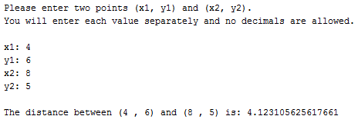



**Copy and paste screen shots of your code and output below and then print this sheet. You may also print your code and output separately if you are unsure of how to do screenshots**



